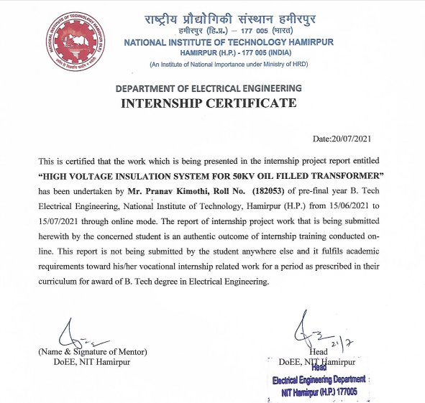

**HIGH VOLTAGE INSULATION SYSTEM FOR 50KV OIL FILLED TRANSFORMER**

A report submitted

in partial fulfillment of the completion of

ONLINE SUMMER TRAINING

*Conducted by:*

*Department of Electrical Engineering*

**

From 15/06/2021 – 15/07/2021

Academic Session 2018-22

**Project Guide Submitted by**

Dr. R.K. Jarial Pranav Kimothi (Roll No:182053)

**TABLE OF CONTENTS**

|  |  |
| --- | --- |
| Topic | **Page No.** |
| LIST OF FIGURES………………………………... | **4** |
| LIST OF TABLES………………………………… | **4** |
| ACKNOWLEDGEMENT…………………………. | **5** |
| CHAPTER 1: INTRODUCTION…………………. | **6** |
| 1.1 Oil filled transformer…………………………... | **6** |
| CHAPTER 2: ISD CODES ON OIL FILLED TRANSFORMERS………………………………… | **8** |
| 2.1 ISD code 2026…………………………………. | **8** |
| Chapter 3: LIQUID DIELECTRICS………………. | **10** |
| 3.1 Classification of liquid dielectrics……………... | **10** |
| 3.2 Insulation breakdown………………………….. | **11** |
| 3.3 Breakdown in liquid dielectrics……………….. | **12** |
| 3.4 Practical values of breakdown strength………... | **14** |
| 3.5 Quantity of transformer oil…………………….. | **14** |
| 3.6 Grading of oils…………………………………. | **15** |
| 3.7 Terminologies related to oils…………………... | **15** |
| 3.8 Tests on transformer…………………………… | **16** |
| 3.8.1 Color test………………………………… | **16** |
| 3.8.2 Dielectric breakdown voltage test………. | **17** |
| 3.8.3 Dissolved gas test……………………….. | **18** |
| 3.8.4 Dissolved metal test……………………... | **19** |
| 3.8.5 Crackle test……………………………… | **19** |
| 3.8.6 Acidity test………………………………. | **19** |
| 3.8.7 Furanic compound test…………………... | **20** |
| 3.8.8 PCB content test………………………… | **20** |
| 3.8.9 Power factor test………………………… | **20** |
| 3.8.10 Flash and Fire point test………………... | **21** |
| 3.8.11 Pour point test………………………….. | **21** |
| CHAPTER 4: REVIEW ON INSULATION ENHANCEMENT TECHNIQUES IN OIL TRANSFORMER…………………………………. | **22** |
| 4.1 Introduction……………………………………. | **22** |
| 4.2 Diagnostic method…………………………….. | **23** |
| 4.2.1 Diagnosis by RVM method……………… | **23** |
| 4.2.2 Diagnosis by FDS method……………….. | **24** |
| 4.2.3 Diagnosis of Sulphur corrosion …………. | **25** |
| 4.3 Enhancement using nanoparticles……………... | **26** |
| 4.4 Alternative to previously used schemes……….. | **30** |
| 4.4.1 Polyester compounds…………………….. | **30** |
| 4.4.2 Ester oil…………………………………... | **32** |
| 4.4.2.1 Thermal overloading capabilities of ester oil………………………………... | **34** |
| CONCLUSION…………………………………….. | **35** |
| REFERANCES…………………………………….. | **36** |

**LIST OF FIGURES**

|  |  |  |
| --- | --- | --- |
| **Fig 1** | Conductivity v/s time…………………………... | 12 |
| **Fig 2** | DC voltage v/s current density…………………. | 12 |
| **Fig 3** | ATSM D1500 standard…………………………. | 17 |
| **Fig 4** | BDV testing kit…………………………………. | 17 |
| **Fig 5** | Gas generation chart……………………………. | 18 |
| **Fig 6** | Acid determination in transformer oil………….. | 20 |
| **Fig 7** | Time behaviour of voltage response and corresponding moisture content………………... | 24 |
| **Fig 8** | Two-step method for preparation of nanofluids... | 27 |
| **Fig 9** | AC breakdown voltage of Mineral v/s Ester oil... | 28 |
| **Fig 10** | Thermal Conductivity of Mineral v/s Ester oil…. | 29 |
| **Fig 11** | Oil temperature of KNAN transformer………… | 34 |

**LIST OF TABLES**

|  |  |  |
| --- | --- | --- |
| **Table 1** | Temperature of oil in various loadings………. | **9** |
| **Table 2** | Specifications of general mineral oil………… | 11 |
| **Table 3** | Dielectric strength of various oils……………. | 14 |
| **Table 4** | Quantity of oil used………………………….. | 14 |
| **Table 5** | Various parameters of transformer oil……….. | 16 |
| **Table 6** | IEEE C57 104-2008 standards………………. | 18 |
| **Table 7** | Comparison of various parameters of nanofluid oil…………………………………. | 27 |
| **Table 8** | Effect of various parameters on BDV and IBV | 28 |
| **Table 9** | Comparison between Aramid and Polyester composite…………………………………….. | 31 |
| **Table 10** | Properties of transformer Insulating oils…….. | 33 |

**ACKNOWLEDGEMENT**

I am really grateful to my mentor Dr. R.K. Jarial for advising me and introducing the project to me in an easy to understand way which has helped me complete my project easily and effectively on time.

I am dearly obliged to work on the topic of HIGH VOLTAGE INSULATION SYSTEM FOR 50 kV OIL TRANSFORMER which gave me an insight about the practical designing of the transformer insulation.

Thank you.



Pranav Kimothi

182053

B.Tech.(EE)

**CHAPTER 1**

**INTRODUCTION**

**1.1 Oil Filled Transformers**

Transformers are essential power system equipment’s which help to transfer energy from one circuit to the other without any change in the frequency. They can be classified into many types such as:

* Distribution and power transformers
* Single-phase and Three-phase
* CT and PT

All the above mentioned will come under either oil filled or dry type transformers. Oil filled transformers are ahead of dry type transformers as they have higher power handling capacity, better efficiency and low sound levels.

Transformer oil is a key element to check and monitor physical conditions of a transformer. With the increase demand in the power in India over the past five decades, it has become important to maintain the efficiency and health of transformer for longer period of time. The liquid dielectric will carry the temperature through both convection and conduction principles generated from different types of windings and core to external cooling components of radiator, conservator and cooling fans. The dissipation of heat is usually facilitated by continuous circulation of oil between the winding and the cooler/radiator. Hence, selection of appropriate heat transfer agent to act as a coolant is essential for transformer applications.

It is useful in preventing overheating and arcing in windings and core of the transformer. The present condition of the oil can also be used as an indicator of the upcoming fault, it’s location and it’s reason by measuring the pollutant particles and their concentration in the oil. Furthermore, the oil in the transformer can be classified into many categories as well. The power rating, voltage rating and environmental conditions of the place also help to determine the type of oil to be used. Therefore, it becomes important to study about the various qualities and their corresponding test that the oil must undergo to be certified to be used as an insulation and as a coolant in the transformer.

In transformer we generally make use of mineral oil but due to its non- biodegradable nature, a large amount of oil causes a threat to the environment. So, past few studies have suggested that we may use Ester oils which have better and similar aspects to that of the mineral oils. Also, these oils are miscible with the mineral oils and transformer does not require any additional modification in the transformer design. Hence, it’s very important to study oil filled transformers to strength the core of power generation.

**CHAPTER 2**

**INDIAN STANDARD CODES ON OIL FILLED TRANSFORMER**

* 1. **IS CODE 2026**

1. For oil-immersed transformers the type of oil preservation system shall be specified in the enquiry and order. The following types are distinguished:

* Freely breathing system or conservator system where there is free communication between the ambient air and an air-filled  
  expansion space above the surface of the oil, in the tank or in a separate expansion vessel (conservator). A moisture-removing breather is usually fitted in the connection to the  
  atmosphere.
* Diaphragm-type oil preservation system where an expansion volume of air at atmospheric pressure is provided above the  
  oil but prevented from direct contact with the oil by a flexible diaphragm or bladder.
* Inert gas pressure system where an expansion space above the oil is filled with dry inert gas at slight over-pressure, being connected to either a pressure-controlled source or an  
  elastic bladder.
* Sealed-tank system with gas cushion, in which a volume of gas above the oil surface in a stiff tank accommodates the oil expansion under variable pressure.
* Sealed, filled system in which the expansion of the oil is taken up by elastic movement of the permanently sealed, usually corrugated tank.

1. Normal ambient temperature limits for oil filled power transformer are between -25 degree C to +40-degree C. If the temperature of the site of deployment of the transformer exceeds this limit, then the temperature rise limits will be reduced by the same amount.
2. Determination of top oil temperature is done using one or more sensors which are immersed in the transformer tank in different locations such as pockets in the cover or in headers such that the effect of coolers or radiators is excluded. For large transformers we generally make use of more than one sensor so that we can take the average of the readings for better simulation.
3. The bottom oil temperature means the temperature of the oil that is entering the windings at the bottom. Sensor are deployed in the return headers from radiators.
4. The ultimate temperature rises Δ $θ_{u}$ of the oil obtained by a least square method of extrapolation of all measured points above 60% can be given by the equation:

Δ $θ_{u}$ = Δ $θ_{2}$ + $\frac{\sqrt{\left(Δθ_{2}-Δθ_{1} \right)-(Δθ_{3}-Δθ_{2}) }}{\ln{\frac{Δθ_{2-} Δθ_{1} }{Δθ_{3}-Δθ_{2} }}}$

1. If the transformer is loaded beyond its limits, the temperature change will cause a change in the moisture and gas content in the oil.
2. Short time emergency loading cause reduction in dielectric strength due to the super saturation of oil or presence of gas bubbles near the windings and leads nearly at 140-degree Celsius and 2% moisture content. It may also cause gassing in condenser type bushing.
3. The top oil temperature limits are given below:

|  |  |  |  |
| --- | --- | --- | --- |
| Top oil temperature in various loadings | Distribution Transformer | Medium power transformer | Large power transformer |
| Normal cyclic | $${105}^{0}C$$ | $${105}^{0}C$$ | $${105}^{0}C$$ |
| Long time emergency | $${115}^{0}C$$ | $${115}^{0}C$$ | $${115}^{0}C$$ |
| Short time emergency | Not specified | $${115}^{0}C$$ | $${115}^{0}C$$ |

**(Table 2.1: Temperature of oil in various loadings)**

**CHAPTER 3**

**LIQUID DIELECTRICS**

All dielectrics are insulators but all insulators are not dielectrics. Transformer oil is an example of a liquid dielectric. Thus, it is important to know about the various properties and classification of the same. Liquid dielectric perform various actions such as:

* Insulation between parts carrying voltage and grounded container.
* Impregnation of paper and tape insulation used in transformer windings.
* Cooling action.
* Filling up of air voids to increase dielectric strength.
* Arc extinction in circuit breakers.

**3.1 Classification of liquid dielectrics**

Liquid insulating materials

Organic

Inorganic

Synthetic

Natural

Highly purified water, liquid Nitrogen and Helium

Halogen free synthetic liquids

Substituted hydrocarbon

Agro products

Petroleum products

* Sowol
* Pyranol
* Clophen
* Polyisobutylene
* Dodecyclicbenzol
* Silicon oil
* Vaseline
* Asphalt
* Bitumen
* Vegetable oil
* Resins
* Wood oil

Amongst the liquid dielectrics mineral oils are most important. These oils consist of saturated hydrocarbons or of paraffinic and naphthenic ${(C}_{n}H_{2n})$ structures beside having an unsaturated aromatic hydrocarbon ${(C}_{n}H_{2n-6})$ in different proportions. If the amount of paraffin and naphthalene oil is same it is said to be a mixed oil. Further, an oil is aromatic if aromatic content is more than 10%. Mineral oils are used in CTs, PTs, oil filled cables and circuit breakers.

|  |  |  |  |  |  |
| --- | --- | --- | --- | --- | --- |
| Oil | $$ԑ_{r}$$ | tan δ | Dynamic viscosity | Density | Electric strength |
| Mineral oil | 2.0 | At ${20}^{0}C$ ≤ ${10}^{-3}$ | At ${40}^{0}C$ $0.0067$-0.0143 (Pa. s) | ≤0.895 ( $g/{{cm}^{3}})$ | $$≥300$$ (${kV}/{cm}$) |

**(Table 3.1: Specification of general mineral oil)**

**3.2 Insulation resistance offered by dielectrics**

The dc resistance offered by any insulating material represents the concept of insulation resistance of a dielectric. Its expression is given as:

$ρ_{ins}= \frac{1}{K_{dc}}$ Ω-m**:** ρ is specific insulation resistance, k is dc conductivity

If a direct voltage $V_{dc}$ is applied across the field electrodes having a uniform layer of insulation oil between them then current is given by:

$i_{dc}$ = $k_{dc}$. A. E: A is the cross-sectional area of fluid.

A graph of the study of dc conductivity of an insulating oil with respect to time of applied voltage is shown below. It is evident that insulation resistance is a function of time.

* In region A dc conductivity is very high and is obtained due to the initial orientation of dipoles i.e., before application of voltage.
* In region B, conductivity is due to movement of free charge carriers under the influence of electric field.
* The region C, represents formation of space charge region in front of electrodes.
* The region D, demonstrates steady ion current due to dissociation.

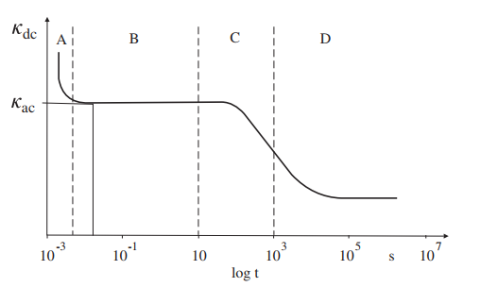

**(Fig 1: Conductivity v/s Time)**

* 1. **Breakdown in liquid dielectrics**

1. 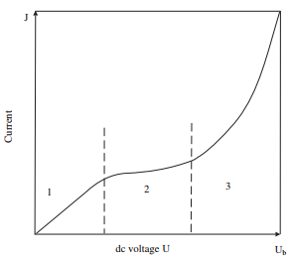The conduction of a liquid dielectric depends upon its purification. A graph showing a plot of conduction current density and applied dc voltage is given below.

**(Fig 2: DC voltage v/s Current density)**

At starting in region 1, the liquid seems to follow the Ohm’s law as the characteristics are linear. On increasing the field intensity, the current gets saturated in region 2 and finally after a certain point in region 3 breakdown occurs. Instead of electrons, ions take part in conduction in liquid dielectrics. The conductivity of the dielectric depends upon temperature according to Van’t Hoffsch law as:

k = $k_{0}exp⁡(-\frac{F}{KT})$ which is valid only for region 1. The conduction phenomenon can be divided into 2 temperature regions.

* Low/room temperature regions where conductivity is governed by ionic carrier mobility.
* High temperature region where conductivity is determined by impurities and carrier mobility.

1. Behaviour of oil is greatly influenced by Electrohydrodynamic. The oil can either be forced by action of pumps or be natural. Conduction current constitutes of impurities in liquid and ions injected from electrode due to electromechanical reactions in metal liquid interface. At normal temperature the former is very small. But at high temperatures charges accumulate in areas with high velocity and the dielectric strength of the oil at those parts is severely affected.
2. The power frequency breakdown also depends upon the moisture content of the oil. At moisture content below than 20 ppm, the dielectric strength is independent of the temperature. However, for moisture contents above 20 ppm and below 100 ppm this breakdown strength is lowest at room temperature. The breakdown strength of a pure oil decreases by 25% when the moisture content is increased to 20 ppm. The chemical reaction between the oil and transformer parts cause iron, copper, cellulose to contaminate the oil which further reduces the dielectric strength of the oil.
3. Aging of the oil also degrades the strength of the oil. However, some studies have resulted that if we use nano particles as suspension in the oil such as TiO2 it can prevent the aging of the oil. They help to achieve this by maintaining uniform electric field over the whole oil medium.

**3.4 Practical values of breakdown strength**

The table shows the practical dielectric strength of various oils by different manufacturers.

|  |  |  |
| --- | --- | --- |
| Company Name | Product Name | Dielectric strength  As delivered/ After treatment  (in kV/cm) |
| Lodha | TO-1020 60 U | 30/70 |
| Savita | TRANSOL - GET | 30/70 |
| Eastto | EASTTO | 30/60 |
| Velvex | 60296-TIT | 30/40 |
| Lubrex-FZC | OPTIMUS 45 | 53/53 |
| Sunrise | IS-12463 | 30/60 |
| HP Lubricants | HP Transformer oil | 73/73 |

**(Table 3.2: Dielectric strength of various oils)**

**3.5 Quantity of oil in transformers**

The following data has been taken from Fuji Electric global company**.** The quantity of the oil depends upon the working voltage level and power rating of the transformer**.** The following are for 33kv-400/230V.

|  |  |  |
| --- | --- | --- |
| Sr No. | Rating in kVA | Oil in liters |
| 1 | 50 | 165 |
| 2 | 100 | 230 |
| 3 | 250 | 350 |
| 4 | 500 | 500 |
| 5 | 1000 | 750 |
| 6 | 1500 | 1200 |
| 7 | 2000 | 1450 |
| 8 | 2500 | 1750 |

**(Table 3.3: Quantity of oil used)**

**3.6 Grading of oils**

The oil can be classified into 3 categories.

* Standard Grade (ST) - Trace inhibited- For use in power and distribution transformers.
* High Grade (HI) - Inhibited- For use in generator, industries, HVDC transformer
* High Grade (HIG) – Inhibited and negative gassing tendency- For EHV instrument transformers.

**3.7 Terminologies related to oils**

1. Flash Point: The lowest [temperature](https://en.wikipedia.org/wiki/Temperature) of a [volatile](https://en.wikipedia.org/wiki/Volatility_(chemistry)) material at which its vapors [ignite](https://en.wikipedia.org/wiki/Combustion) if given an ignition source.
2. Fire Point: The fire point of a [fuel](https://en.wikipedia.org/wiki/Fuel) is the lowest temperature at which the vapor of that fuel will continue to burn for at least five seconds after ignition by an open flame of standard dimension. At the [flash point](https://en.wikipedia.org/wiki/Flash_point), a lower temperature, a substance will ignite briefly, but vapor might not be produced at a rate to sustain the fire.
3. Pour Point: The fire point of a [fuel](https://en.wikipedia.org/wiki/Fuel) is the lowest temperature at which the vapour of that fuel will continue to burn for at least five seconds after ignition by an open flame of standard dimension.
4. Density: Ratio of mass to volume of the oil.
5. Acidity: This occurs due to the substantial amounts of naphthenic acids (NAs) or other acids i.e., organic compounds in the oil.
6. Resistivity: The oil act as a dielectric so it must have high resistivity (property of material).
7. Viscosity: Viscosity can be conceptualized as quantifying the internal [frictional force](https://en.wikipedia.org/wiki/Friction) that arises between adjacent layers of fluid that are in relative motion.
8. Dissipation factor: It indicates the inefficiency of material to hold energy or behave as an insulating material. The lower the dissipation factor, the more efficient is the insulator system.

The table given below demonstrates some of these parameters for the various transformer oils manufactured by VELVEX industries.

|  |  |  |  |  |  |  |
| --- | --- | --- | --- | --- | --- | --- |
| Model Name | Density at ${29.5}^{0}C$ (g/ml) | Viscosity at ${27}^{0}C$ (cSt) | Flash Point  ( $0_{C}$) | Pour Point  ( $0_{C}$) | Acidity  (Mg KOH/gm) | Dissipation Factor at ${90}^{0}C$ |
| UT | 0.89 | 27 | 140 | -6 | 0.03 | 0.002 |
| 60296-TIT | 0.895 | 12 | 135 | -40 | 0.01 | 0.005 |
| 60296-UT | 0.895 | 12 | 135 | -40 | 0.01 | 0.005 |
| 12463-IT | 0.89 | 27 | 140 | -6 | 0.03 | 0.002 |
| 60296 | 0.895 | 12 | 135 | -40 | 0.01 | 0.005 |

**(Table 3.4: Various parameters of transformer oil)**

**3.8 Tests on transformer oil**

**3.8.1 Color Test**

As the name suggests, the oil sample is compared with a previous sample from the same transformer and is checked for darkening of oil. The color of the oil is determined by transmitting a light and is given a numerical value between 0-5 which is compared with a series of color standards. If noticeable darkening of oil is observed it is safe to assume that the oil is either contaminated or internal arching has occurred in the transformer. The international method used is ASTM D1500.ATSM D1500 is an American standard for color testing of various types of oils.

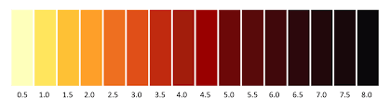

**(Fig 3: ATSM D1500 Standard)**

**3.8.2 Dielectric Breakdown Voltage Test**

We perform the test using BDV testing kit which contains two electrodes of 12.5 mm diameter separated by a fixed gap of 2.5 mm in a glass container. The oil is poured in the container and the container is kept inside between a phase and neutral winding of an inbuilt transformer. The voltage of the transformer is varied using a variac switch at the front of testing kit. Start the push button and raise the voltage manually. The upper limit of the variac goes to 100-120kV. At a particular voltage sparking will occur between the two electrodes and a digital display on the panel shows the corresponding electric field. The minimum dielectric strength of the oil must be 35kV below 220kV transformers. If the dielectric strength is found less, the oil must be purified or replaced.

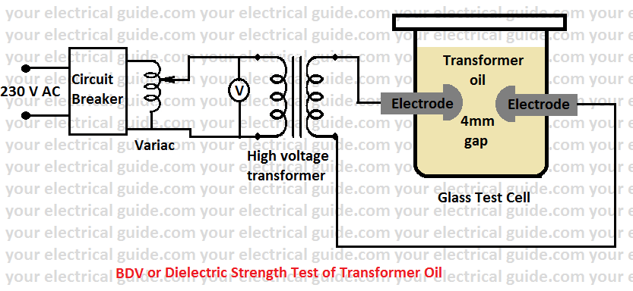

**(Fig 4: BDV testing circuit)**

**3.8.3 Dissolved gas analysis**

It is the study of dissolved gases in the oil which demonstrates the condition of transformer. On running condition the transformer undergoes electrical and mechanical stress due to which overheating and sparking occurs and the oil at these location gets overheated and gets decoes into various gases such as hydrogen, methane, ethane, ethylene, acetylene, nitrogen, oxygen, carbon dioxide,carbon monoxide. These gases start to from after 140 degree celcius as shown in the figure 3.5 given below. The limit of the concentration of these gases acoording to IEEE standards are as shown. This test is done after 6-12 months on transformer. It helps to detect upcoming fault, monitor transformer health etc.

|  |  |  |
| --- | --- | --- |
| Sr. No. | Gas | Max. Concentration in µl/L |
| 1 | Hydrogen | 100 |
| 2 | Methane | 120 |
| 3 | Carbon Monoxide | 350 |
| 4 | Acetylene | 1 |
| 5 | Ethylene | 50 |
| 6 | Ethane | 65 |

**(Table 3.5: IEEE C57 104-2008 standards)**

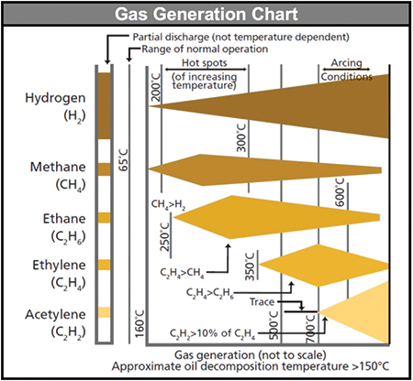

**(Fig 5: Gas generation chart)**

**3.8.4 Dissolved metal test**

This test is done with the help of inductively coupled plasma atmonic emission spectrometry (IC-PES) to determine the presence of any metal which could originate either because of overheating, arcing inside the transformer or maybe because of mechanical wear. This test helps to determine the exact location of the type of fault determined by DGA test.

**3.8.5 Crackle test**

It is done to determine the moisture content in the transformer oil. To perform this test we take a beaker and pour 250 ml oil into the beaker. Then we take a heated iron rod of 12.5 mm and will pour it into the beaker. If moisture is present then it will produce a hissing sound. This sound showcases the presence of moisture so, the oil must be treated. The sources of the moisture are breathing, repair of transformer, aging of paper insulation.

**3.8.6 Acidity test**

This test determines the acidity of the transformer oil using a testing kit. We take 1.1 ml of oil which is treated as 1 gm in weight. We then add 1 ml of rectified spirit to our sample as acid in the oil is highly soluble in the spirit. After shaking the sample we add 1 ml of sodium bicarbonate and shake it again. At the end we use 5 drops of universal indicator in the sample. The color thus obtained demonstrates the acidity value in terms of KOH/gm. Acidity occurs due to the oxidation of the oil when it comes in contact with the air. This causes a decrease in the resistivity of the oil, increase in dissipation factor and acceleration of sludge formation.

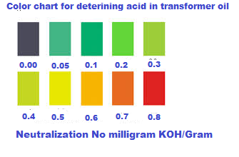

**(Fig 6: Acid determination in transformer oil)**

**3.8.7 Furanic compound test**

This test is carried out as per ASTM D5837 in which measurements are made using high-performance liquid chromatography or HPLC. This test helps us to determine the presence of cellulosic material either from the paper insulation of the windings or press board which generates Furanic compounds in the oil.

**3.8.8 Polychlorinated Biphenyls (PCB) Content**

Detects the concentration level of polychlorinated biphenyls in transformer oil by gas chromatography. Measured in ppm, it also applies to the determination of PCB present in mixtures known as askarels.

**3.8.9 Power factor test**

Tan Delta which is also termed as Dielectric Dissipation or Loss Angle or [Power Facto](https://www.elprocus.com/power-factor-calculation/)r testing method which is performed for testing of insulating oil to know the quality level of the oil. This kind of testing methodology is carried out at two [temperature levels](https://www.elprocus.com/ds18b20-temperature-sensor/). The results that are obtained from the two tests are compared and then consideration is taken in the quality level of the coil. If the test results are good, the oil is continued in service and when the test results are not as expected, then either replacement or change in oil takes place. The main purpose of the tan delta test is to make sure of maintaining a secure and reliable functioning of the transformer. With the calculation of dissipation factor and [capacitance values](https://www.elprocus.com/miller-effect-effect-of-miller-capacitance/), it provides the result of [insulation](https://www.elprocus.com/idc-insulation-displacement-connector/) behavior of bushings and in windings too.

**3.8.10 Flash and fire point test**

This test is used to check the volatility of the oil. It is the minimum temperature at which the heated oil starts to give out sufficient vapour to form a flammable moisture with the air. The international standard used for this test is ASTM D92.

**3.8.11 Pour point test**

This test is really important especially if the transformer is located in a very cold climate. In this this test the lowest temperature is determined at which the oil will flow thus making sure that the will circulate and serve its purpose as an insulation.

**CHAPTER 4**

**REVIEW ON INSULATION ENHANCEMENT TECHNIQUES IN OIL TRANSFORMER**

**4.1 Introduction**

Transformers are critical component of power system. Insulating oil provides a way to enhance the capabilities of the transformer. Due to the increase in the electrical power demand, the voltage levels of the transmission equipments used in a transmission system increases which requires certain changes in the thermal and electrical structure of a transformer. The insulation inside a transformer goes under electrical, mechanical, chemical and thermal stresses which causes the prematuer aging of the transformer and cause insulation failiures. Transformer failiures are caused by insulation damaging in majority of the cases. So, it becomes important to search for better effective measures to solve this problem. A study shows that insulation failiure caused transformer life to get reduced to 17.8 years which is roughly half the expected life of a working of transformer[9]. A transformer insulation can be studied by reviewing the nature of its oil and cellulose paper that is used in its windings.

The methods of enhancing the insulation can be classified in broadly 3 categories which are as follows:

1. Using an alternative of insulating material.
2. Enhancing the chemical, thermal and electric properties of the popular known insulating materials using nano-chemistry.
3. Using proper diagonistic tools to moitor oil health precisely and purifying the oil to remove unwanted compounds over regular time intervals non destructively.

**4.2 Diagnostic Methods**

Operating condition is the best way to monitor a tranformer health and predict the upcoming faults in a transformer. During the aging process, several parameters of the oil get changed. As, already discussed BDV test, pour point test, fire point test etc. are individual tests and require much time to come at a definite point. Furthermore, these tests are of destructive nature i.e. the oil used to determine the fire and flash point can’t be used again in the transformer. These tests depict a partial picture of a transformer’s condition. So, we go with new and compact tests a which help us to monitor in an easy and time efficient manner.

**4.2.1 Diagnosis by Return Voltage Method (RVM)**

It is a time domain technique which is applicable to both oil and insulating paper in a transformer. It is based on the method of capturing very low current involved in dielectric relaxation process. It can be used without opening the tank of the transformer.

The steps involved in this method are as follows[1]:

1. LV and HV windings of atransformer are connected to a step voltage of 100 Volts applied between the windings for time $t_{N}$. The capacitor formed by the insulating system is therefore charged slowly.
2. LV and HV windings are then discharged for $t_{V}$ = $t_{N}/2$ by short circuiting the windings.
3. We measure the maximum voltage of the resulting system.
4. This is recovery step before another cycle of time $t_{N}$.

This method determines the moisture level of oil-paper dielctric. This test was performed at 22 /0.4 kV 30kVA transformer which results the following[1]:

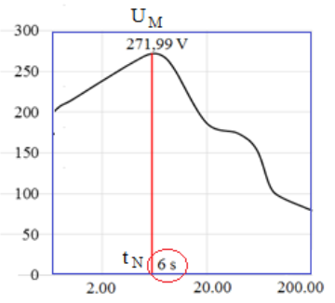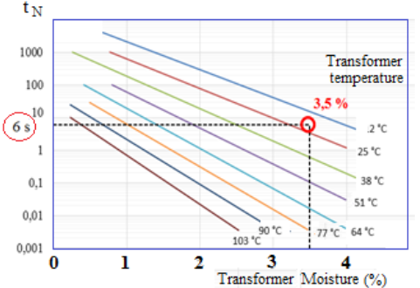

**(Fig 7: Time behaviour of voltage response and corresponding moisture content [1].)**

The advantage of this method is that it gives results quickly but for a new tramsformer voltage required for maximum step response can go upto 2kV which will create additional losses in the system. The shorter the charging time, the greater the moisture content in the oil [1].

**4.2.2 Diagnosis by Frequency Dielectric Spectroscopy (FDS)**

It is a frequency domain method which is used to compute health of insulating oil and paper[1]. This test is better than dielectric dissipation factor test, dielectric adsorption test etc as it covers a wide range of frequency which helps us to distuingish the amount of losses created by oil and paper separately. The frequency response obtained in a power transformer is mainly due to cellulose insulation, oil and interfacial polarization. The frequency limits may vary according to the conductivity of the oil, insulation temperature, moisture and ageing of the oil[1].

It uses MEGGER IDAX 350 instrument which has frequency range of 10kHz to 1MHz. We have to enter the temperature and other transformer parameters into the instrument and it provides us with the modelling curves for the same.

The advantage of this method is that conductivity and loss factor can be easily determined but on the other hand it requires us to measure very small currents which requires high precision of the instrument.

Both, the above methods have a same problem that temperature error correction has to be introduced if the transformer being tested is under loading conditions and not simply present in the laboratory.

**4.2.3 Diagnosis of Sulphur corrosion**

Sulphur compounds present in the oil react with the copper present in the windings to form C uprous sulphide which then gets attached to the copper wires causing decrease in electrical performance of the transformer and sometimes leading to insulation failure.

Sulphur is already present in mineral oils nearly about 0.001-0.05% in various forms such as thiophenes, sulphides, disulphides and polysulphides. Disulphides among all is the major reason of corrosion. In a study in China it was found that 29 of 201 transformer had failiures due to Sulphide corrosion.

The mechanism of corrosion is as follows[3]:

1. Copper react with sulphide to form copper sulphide which is granular in shape.
2. These granules initially deposit in the copper surface and then move to insulation paper.
3. Dibenzyl sulphide (DBS) and diphenylethane ( BiBz) are also produced in the process.

The Sulphide value is directly proportional to the DBS value which leads to decrease in the BDV, volume resistivity and increase in dielectric constant. The Sulphide deteroiation is dependent on the initial value of DBS value which is linked to the voltaage rating of the transformer. As a result major deposition is seen across the HV winding. If corrosion occurs then beyond a point thermoelectric breakdown of insulation occur. Suplhides get formed when the temperature of the oil goes beyond 80 degree Celsius.

The concentration of sulphide can be checked by scanning electronic microscopic images or by using gas chromatography mass spectrometer [3].

The solutions to the above problems are [3]:

1. Initially ASTM D 1275 B standard test must be carried out on the oil to find initial sulphur content. This content must be measured on regular basis through chromatography process.If a sudden increase in the carbon monoxide and carbon dioxide gases is observed then sulphur test must be carried out immediately.
2. Oxygen has been found to increase the formation of copper sulphide by 10-15%. So, the transformer must be completely sealed and breather’s silica gel balls must be changed from time to time.
3. Addition of various passivators to the oil such as Tolyltriazole which can react with oxygen to inhibit the process and also form a protective film on the surface of copper winding.

**4.3 Enhancement using Nanoparticles**

Any particle having size in the range of 1nm to 100nm is called a nanoparticle. Recent studies in the field shows an increase in the breakdown strength after addition of certain nanoparticles in the oil. It is thus benificial to be used in HVAC and HVDC systems. The nanoparticles suitable to be used as suspension in the oil can be categorized as follows [9]:

1. Conductive (${Fe}_{3}O_{4}$, ZnO, SiC)
2. Insulative (Si $O_{2}$, ${Al}_{2}O_{3}$)
3. Semiconductive ( Ti $O_{2}$, CuO, ${Cu}_{2}O$)

A general preparation of nanofluids is done as shown in figure below.

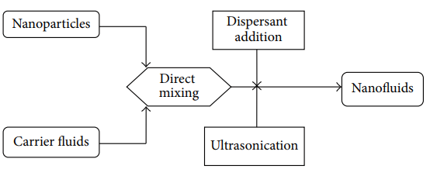

**(Fig 8: Two-step method for preparation of nanofluid [9])**

Study is done on each category of nanoparticle i.e. we take ZnO, Si $O_{2}$, Ti $O_{2}$ (one from each category) and prepare a solution of 0.075%(w/V) to form nanofluid. These are prepared by dispersing them separately in magnetic stirrer at 1200 rpm, 40 degree Celsius for 4 hours. The values of base mineral oil were noted and compared to the oil with nanoparticles which resulted in the following data.

|  |  |  |  |  |
| --- | --- | --- | --- | --- |
| Properties | Base oil | Ti $O_{2}$ | Si $O_{2}$ | ZnO |
| Breakdown Voltage (kV) | 32 | 38.4 | 44.6 | 45 |
| Flash Point ($o_{C}$) | 160 | 160 | 160 | 160 |
| Fire Point ($o_{C}$) | 170 | 180 | 180 | 180 |
| Viscosity (Cst) | 40 | 40 | 40 | 40 |

**(Table 4.1: Comparison of various parameters of nanofluid oil [5])**

In a related test study the samples were kept for 6 months and observation was done that no sedimentation of nanoparticles occurred which demonstrates this method is practically pheasible too [9]. The result shows us the following relations:

|  |  |  |
| --- | --- | --- |
| Effect of | AC breakdown voltage | Impulse breakdown voltage |
| Moisture | Decrease with increase in moisture | No effect |
| Nanoparticle conc. | Increases till a certeain point and then decreases with increase in conc | Increases till a certeain point and then decreases with increase in conc |
| Nanoparticle type | Varies from one to the other due to different relaxation time | Varies from one to the other as polarization is different for each nanoparticle. |

**(Table 4.2: Effect of various parameters on BDV and IBV)**

In a similar other test which was conducted between nanofluids of mineral oil and nanofluids of Ester oil, it was found that the latter had less AC breakdown voltage due to the presence of larger amount of moisture but exhibited better thermal capabilities [2]. Ester oil taken was MIDEL-7131and mineral oil was POWEROIL 355X and suspension was created using Si $O_{2}$ nanoparticles with (w/V) ratio of 0, 0.1, 0.3, 0.5, 0.7.

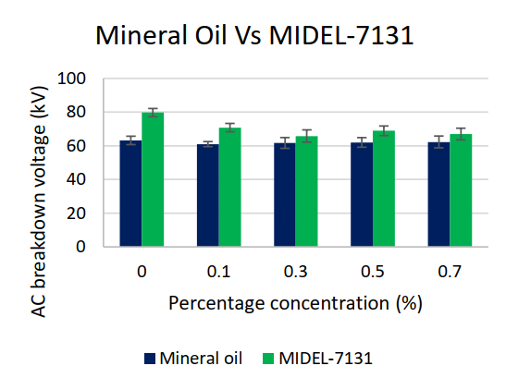

**(Fig 9: AC breakdown voltage of Mineral v/s Ester oil [2])**

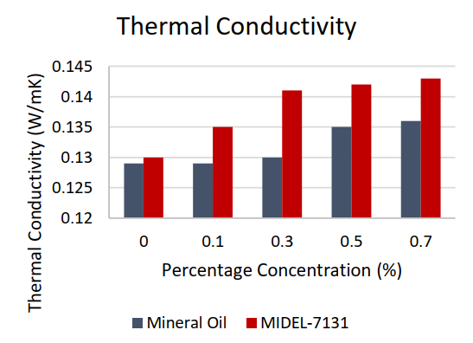

**(Fig 10: Thermal conductivity of Mineral v/s Ester oil [2])**

The major challenges and their proposed solution are as follows:

1. Agglomeration of nanoparticles which causes sedimentation of these particles giving probable rise to insulation failure so we must make use of surfactants which will enhance the stability of nanoparticles by decreasing their surface tension [9].These contain a hydrophilic polar head and a hydrophobic tail portion (Usually long chain hydrocarbons).
2. We can not directly use them in existing transformer as we may see a mismatch in electrical specfication so more reasearch work is needed to find new methods and reduce production cost [9].
3. The nanoparticles can be formed by Single step method or Two step method.Single step method is useful to create high conductivity nanofluid in batches. Due to batch mode of producton it has limited control over particle size. Whereas, the other method is used to create nanofluids coating oxide particles. This method is prone to agglomeration at higher volumes [9]. So, it becomes difficult to go with either one of these methods to arrive at satisfactory results. Also, these process make nanofluids uneconomical.
4. Nanoparticles are not environment friendly and may cause respiratory problems in humans which makes them unsuitable to be used in transformer which needs manual maintenance.

**4.4 Alternative to previously used schemes**

The insulation system consists of cellulose paper and mineral oil which can be replaced such that their new replacement does not require any additional modifications in electrical and thermal design of a transformer. The major proposal have been to use aramid papers and ester oil as a new alternative.

**4.4.1 Polyester composites**

Cellulose and Aramid papers are widely used as solid insulation in a transofmer but their properties can be improved further. Cellulose paper absorb water during cooing process and deabsorb durinh heating causing instability. The water comes throgh the outer atmosphere due to the poor sealing of the transformer and overused silica balls in the breather. The maximum water content that a mineral oil can withstand is 50 ppm [7].

Every soild insulation must possess the property of oil impregnation so that it can be used as an alternative. Furthermore, its dielctric constant must be in between 2.2 to 3.5 so that it can interact with the transformer oil which has an dielctric constant of generally 2.2.Otherwise, this would lead to breakdown and stress formation [7].

A new idea was given to use a polyester composite based paper which has micro-porosity quality which improves the ability to absorb the oil. These have better dielctric properties and better breakdown strength. The polyester composite referenced is QUIN-Tek 163 manufacturedby QUIN-T Corp. Tilton, N.H. The new polymer insulationmaterial is a joint development of MagneTek, Inc., Waukesha, Wisconsin, and QUIN-T Corp., Tilton, New Hampshire.

The polyester composite resulted in the following data with respect to its competitor Aramid paper.

|  |  |  |  |
| --- | --- | --- | --- |
| Sr.No. | Property | Aramid paper | Polyester composite |
| 1 | Compressibility | 3.4% | 14.9% |
| 2 | Moisture at ${25}^{o}C$ | 12 ppm | 8 ppm |
| 3 | Acid number | 0.11 | 0.13 |
| 4 | Recovery | 92.6% | 92.3 |
| 5 | Partial discharge voltage for 0.06mm  (kV/mm) | 45 | 60 |
| 6 | Dissipation factor at ${50}^{o}C$ | 1 | 0.40 |
| 7 | Dielectric strength at 60 Hz  (kV/mm) | 47 | 62 |
| 8 | Impulse breakdown at 0.6 mm | 115 | 112 |

**(Table 4.3 Comparsion between aramid and polyester composite [7])**

It is evident from the above table that polyester composite is better or equal to aramid paper and can be used an a new alternative to the predominantly used cellulose,aramid, kraft papers.

Their only disadvantage is that their cost is comapritively higher and their fabrication process is not as easy as the others.

**4.4.2 Ester oil**

Conventionally, mineral oil is used in the transformers but now-a-days ester oil have gained importance in the transformer insulating applications due to their higher fire point, better thermal performance and biodegradability. Hence, considering their environmental friendliness and the fire safety benefits, the transformer utilities are now-a-days prefer to ester oils for transformer applications replacing the conventional petroleum origin based mineral oil. Ester oils have more polar contents than mineral oil due to their ester linkages [4]. Ester oils are of two types:

* Synthetic (eg. MIDEL-7131)
* Natural (eg. MIDEL En 1215(Soyabean oil))

A detailed comparison between mineral,synthetic and natural ester oil was done using ATSM D3455 standards which involved preparation of test samples and keeping it in contact with the oil for 164 hours after which tests were performed [4].These test involved observing of following parameters:

* Breakdown strength
* Dissipation factor
* Interfacial tension
* Acid number
* Color
* Thermal effects

Some basic information about insulating oils is given in the table below.

|  |  |  |  |
| --- | --- | --- | --- |
| Property | Mineral oil | Natural ester oil | Synthetic ester oil |
| Relative permitttivity | 2.2 | 3.3 | 3.2 |
| Moisture saturation in ppm at ${20}^{o}C$ | 55 | 1100 | 2200 |
| Acid number in mg KOH/g | 0.01 | 0.04 | 0.03 |
| Breakdown voltage in kV at 2.5mm gap | >70 | >75 | >75 |
| Dissipation factor at ${90}^{o}C$ | <0.001 | 0.02 | 0.03 |
| Viscosity at ${40}^{o}C$ in ${mm}^{2}/sec$ | 9.1 | 35 | 28 |
| Interfacial tension in mN/m | 40 | 24 | 25 |

**(Table 4.4: Properties of transformer insulating oil [4] )**

The study gave the following results:

1. Breakdown strength of mineral oil < synthetic ester < natural ester oil because of the moisture handling capabilities of the oils.
2. Dissipation of mineral oil is less than ester oils as they possess special ester linkages between them.
3. Interfacial tension decreases by 10% in mineral oil, 8% in natural ester oil and 14% in synthetic ester oil.
4. Acid number are highest for synthetic ester oil followed by natural ester and mineral oil. It causes fast aging of the machine which is not desirable.

**4.4.2.1 Thermal overloading capabilities of ester oil**

Even after greater electrical properties of ester oil over mineral oil, it is still a technical problem to utilize them in transformers due to their high viscosity (3x times of mineal oil) which may lead to reduction in heat dissipation in convection process. This may lead to higher temperature of the top oil and windings[6]. A study demonstrated these effects investigated using Thermal hydraulic network model (THNM) on 60 MVA, 220/33kV transformer. The top and bottom oil temperature results were as shown:

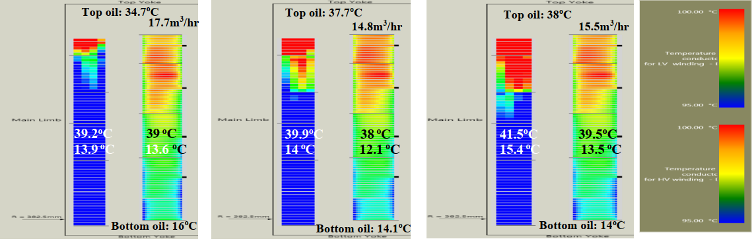

**(Fig 11: Oil temperature for KNAN transformer)**

The flow rate of the oil and percentage total heating in transformer winding is weakly coupled in oil directed modes of coling [6]. If flow of the oil is fast due to lower viscous nature of the oil properties, then convective principle will surely be faster. Therefore, convection fluid currents will be less quantity in ester oil which will lead to higher temperature distribution.High flow rate of the ester oil does not imply a better thermal performance of transformer because, too high rate of oil flow will also lead to reverse flow of oil in the oil pass bottom duct in oil directed cooling mode[6]. From the analysis it was concluded that the existing thermal design guidelines of the mineral oil are not applicable for ester oil filled power transformer if we consider continuous overloading capabilities. If retrofilling in mineral oil filled transformer are considered with the ester oil for continuous overloading benefits, then it is advisable to go for thermal parameters analysis based on geometry of the winding due to higher hot-spot temperature and also considering cellulose paper in the winding conductors.

**CHAPTER 5**

**CONCLUSIONS**

We acknowledged the need of attention towards insulation system in a transformer and ways to do it. Research work in this area has been challenging and has a great room of opportunities ahead. This report had introduction to the types of insulating materials, their specifications and several test that are needed to be performed to ensure their quality. A review to enhance the current scheme is also done in broadly 3 categories. Although many problems have been spotted but none of the rectification sounds fruitful to directly be applied to the existing transformers. The nanofluids and corrosion phenomenon must be analyzed more deeply from the atomic perspective to come at a better solution. A combination of all the 3 methods discussed in this report might be the new research topic for the coming future. This report clearly indicates that mineral oil seems insignificant in comparison to nanofluids and ester oil in some major aspects such as breakdown voltage which clearly indicates that it may lose its popularity in the coming decades.

**REFERANCES**

1. Gutten M, Kucera M, Brncal P, Sebok M, Korenciak D. Analysis of insulating parameters of oil transformer by time and frequency  
   methods*.* Diagnostyka. 2020;21(4):51-56. <https://doi.org/10.29354/diag/128607>
2. D. Ch Shill, A. K. Das and S. Chatterjee, "Insulation and Cooling Performance of Transformer Oil Based Nanofluid," *2020 International Conference on Computer, Electrical & Communication Engineering (ICCECE)*, 2020, pp. 1-4, doi: 10.1109/ICCECE48148.2020.9223077.
3. Cong H, Pan H, Qian D, Zhao H, Li Q. Reviews on sulphur corrosion phenomenon of the oil–paper insulating system in  
   mineral oil transformer. *High Voltage*. 2020;1–17.  
   <https://doi.org/10.1049/hve-2020-0060>
4. A. Garg, A. Jain, J. Velandy, C. S. Narasimhan, J. D. Patil and S. S. Beldar, "Compatibility of ester oil with transformer components and comparison with mineral oil," *2019 IEEE 4th International Conference on Condition Assessment Techniques in Electrical Systems (CATCON)*, 2019, pp. 1-6, doi:10.1109/CATCON47128.2019.CN0011.
5. Bakrutheen, M. & Karthik, radha & R., Madavan. (2013). Investigation of critical parameters of insulating mineral oil using semiconductive nanoparticles. Proceedings of IEEE International Conference on Circuit, Power and Computing Technologies, ICCPCT 2013. 294-299. 10.1109/ICCPCT.2013.6529039.
6. Velandy, Jeyabalan & Garg, Ankita & Narasimhan, C.. (2020). Continuous Thermal Overloading Capabilities of Ester Oil Transformers in Oil Directed Cooling Conditions. 1-7. 10.1109/PIICON49524.2020.9113026.
7. Golner, T.M.. (1993). Development of new insulation system for use in oil-filled transformers[C]. Membrane Technology. 529 - 532. 10.1109/EEIC.1993.631250.
8. Perkasa, Caesar & Lelekakis, Nick & Wijaya, Jaury & Martin, Daniel. (2012). Investigating bubble formation in vegetable and mineral oil impregnated transformer paper insulation systems. 1-5.
9. Rafiq, Muhammad & lv, Yuzhen & Li, Chengrong. (2016). A Review on Properties, Opportunities, and Challenges of Transformer Oil-Based Nanofluids. Journal of Nanomaterials. 2016. 1-23. 10.1155/2016/8371560.